**Subject: 20CS2036L – Web Technology Lab Reg No: URK22AI1048**

**Lab Exercise: 1. Design a webpage using HTML (Duration: 1 hour)**

**Create a HTML webpage for your Personal Profile that conforms to HTML5 standards and has the following elements:** doctype, html, meta (in the revised html5 format), title, head, body, div, p, headings, image, anchor, table, list, html comment

1. Your site is very simple. Personalize the content.
2. It consists of a page heading and sections. Each section contains a sub heading and some text. 3. Header section: Heading
3. Section 1: table with one row and two columns, border not visible. Left column: user details, Right column: Photo
4. Section 2: dummy text if needed + all types of hyperlinks [external link with target, internal link, email link, phone link, download link and clickable image].
5. Section 3: text formatting [<div>, <p>]
6. Section 4: dummy text if needed + table in the given format to display information in rows and columns. [use caption, thead, tbody, tfoot, rowspan and colspan].
7. Section 5: dummy text + definition list, ordered list, unordered list, and nested list.
8. Nav section: hyperlinks with bookmark [navigation within a page].
9. You are NOT allowed to use <br> tag and any CSS.
10. Appropriate use of HTML comments.
11. Set a background color and text color as per your wish, align the content in the web page [use style attribute].
12. All HTML pages must pass the official HTML5 specifications via<https://validator.w3.org/>
13. Publish your website live on web using any free web hosting services (000webhost).
14. Use the mockup illustration page given below.

**Description:**

Hypertext Markup Language (HTML) is the standard markup language for documents designed to be displayed in a web browser.

# Working with Tables

The HTML tables are created using the <table> tag in which the <tr> tag is used to create table rows and <td> tag is used to create data cells. The elements under <td> are regular and left aligned by default. colspan attribute used to merge two or more columns into a single column. Similar way rowspan is used to merge two or more rows. The caption tag will serve as a title or explanation for the table and it shows up at the top of the table. You can use one table inside another table. Not only tables you can use almost all the tags inside table data tag <td>.

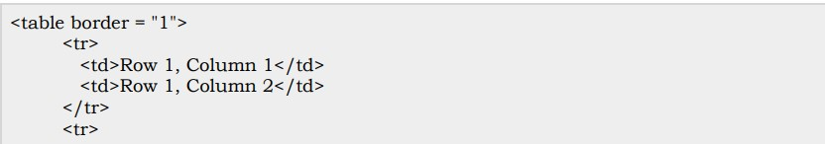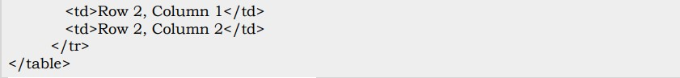

# Working with list

HTML offers web authors three ways for specifying lists of information. Lists may contain −

* <ul> − An unordered list. This will list items using plain bullets.
* <ol> − An ordered list. This will use different schemes of numbers to list your items.
* <dl> − A definition list. This arranges your items in the same way as they are arranged in a dictionary.

Type attribute for <ul> tag to specify the type of bullet you like. By default, it is a disc.

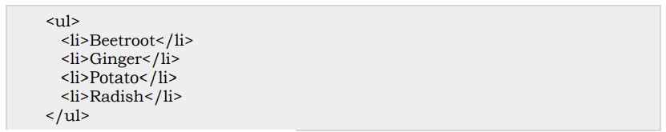

# Working with Text

* <abbr> tag defines an abbreviation or an acronym.
* <blockquote> tag specifies a section that is quoted from another source.
* <cite> tag defines the title of a work (e.g. a book, a song, etc.).
* <code> tag is a phrase tag. It defines a piece of computer code.
* <em> tag is a phrase tag. It renders as emphasized text.
* <h1> to <h6> tags are used to define HTML headings.
* <mark> tag defines marked text.
* <pre> tag defines preformatted text.
* <span> tag is used to group inline-elements in a document.
* <sub> tag defines subscript text.
* <sup> tag to define superscripted text
* <p> element defines a paragraph

# HTML Entities

Some characters are reserved in HTML. Character entities are used to display reserved characters in HTML. To display a less than sign (<) we must write: &lt;

# Working with links

HTML links are hyperlinks. It links another document. The target attribute specifies where to open the linked document.

The target attribute can have one of the following values:

* _blank - Opens the linked document in a new window or tab
* _self - Opens the linked document in the same window/tab as it was clicked (this is default)
* _parent - Opens the linked document in the parent frame
* _top - Opens the linked document in the full body of the window

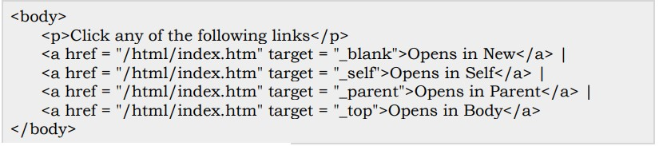

# Bookmark

HTML bookmarks are used to allow readers to jump to specific parts of a Web page. Bookmarks can be useful if your webpage is very long. To make a bookmark, you must first create the bookmark, and then add a link to it.

# Image

Images are very important to beautify as well as to depict many complex concepts in simple way on your web page. Insert any image in your web page by using <img> tag. src attribute specify the location of the image file. Image name is always case sensitive. The alt attribute is a mandatory attribute which specifies an alternate text for an image, if the image cannot be displayed. You can set image width and height based on your requirement using width and height attributes.

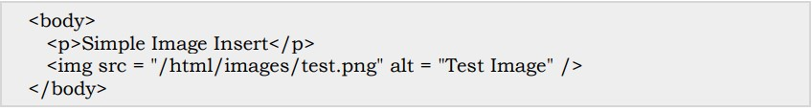

Here is the mockup illustration of the site. Your final result should look very close to this mockup.

**Code :**

<!DOCTYPE html>

<html lang="en">

<head>

<meta charset="UTF-8">

<meta http-equiv="X-UA_Compatible" content="IE=edge">

<meta name="viewport" content="width=device-width, initial-scale=1.0">

<title>MY RESUME PAGE</title>

<link rel="icon" type="image/x-icon" href="fav.jpg">

</head>

<body>

<h1 style="text-align: center;">MY RESUME PAGE</h1>

<div>

<table width="50%">

<tr align="left">

<td width="70%">

<pre><b> HARIHARAN K

177/D Anna Veedhi

Mayiladuthurai Dt

Tamilnadu 609001

Ph No:70920033788

hariharank@karunya.edu.in

</b></pre>

</td>

<td width="50%">

<img src="https://myresumepage1476.000webhostapp.com/img1.png" width="100" height="100" alt="MY PIC">

</td>

</tr>

</table>

</div>

<hr>

<a href="#" target="_blank">Visit 💜 My Website</a>&nbsp;&nbsp;||

<a href="https://karunya.edu" target="_blank">Visit My College</a>&nbsp;&nbsp;||

<a href="mailto:hariharank@karunya.edu.in" target="_blank">Send email</a>&nbsp;&nbsp;||

<a href="">Download CV to Click <sup>--></sup> </a>&nbsp;

<a href="resume.pdf" download target="_blank"><sub>

<img src="/dw.png" width="2%" height="4%" alt="My Page">&nbsp;&nbsp;||</sub>

</a>

<a href="https://www.linkedin.com/in/hari-haran-k-08a8a1249/" target="_blank">Linkedin <sub><img src="li.jpg" width="2%" height="1%%" alt="Linkedin"> </a> &nbsp;&nbsp;|| </sub>

<a href="https://www.instagram.com/hari_1476_/" target="_blank">Instagram <sub> <img src="in.jpg" width="2%" height="1%%" alt="Instagram"></a>&nbsp;&nbsp;||</sub>

<a href="https://github.com/hariharan1476" target="_blank">Github <sub><img src="gt.png" width="2%" height="1%%" alt="Github"></a>&nbsp;&nbsp;</sub>

<hr>

<h3 id="a">Career Objectives</h3>

A career objective is a brief statement that summarizes your professional goals and aspirations. It is usually placed at the top of your resume, just below your name and contact information.To secure a challenging position in a reputable organization to expand my learnings, knowledge, and skills.

Secure a responsible career opportunity to fully utilize my training and skills, while making a significant contribution to the success of the company.

Seeking an entry-level position to begin my career in a high-level professional environment.

To secure employment with a reputable company, where I can utilize my skills and business studies background to the maximum.

Seeking a challenging career with an MNC.

A highly organized and hard-working individual looking for a responsible position to gain practical experience.

<hr>

<h3 id="b">Academic Profile</h3>

<div>

<table width="100%" border ="3px solid black" style="border-collapse: collapse;">

<tr>

<th></th>

<th style="text-align: center;">Educational Details</th>

<th></th>

</tr>

<tr>

<th>Education</th>

<th>School/College</th>

<th>Grade/Percentage</th>

</tr>

<tr>

<td>B.tech</td>

<td>KARUNYA UNIVERSITY</td>

<td>8.5 CGPA</td>

</tr>

<tr>

<td>HSC</td>

<td>SILVER JUBILEE HR SEC SCHOOL</td>

<td>85%</td>

</tr>

<tr>

<td>SSLC</td>

<td>SILVER JUBILEE HR SEC SCHOOL</td>

<td>90%</td>

</tr>

</table>

</div>

<hr>

<h3 id="c">Technical Skills</h3>

<ol><li>Data Structures

<li>Computer Networks

<li>Web Technology

<li>Python Programming

<li>Java Programming

<li>C Programming

</li>

</ol>

<hr>

<h3 id="d">Advanced Technology Skills</h3>

<ul>

<li>Data Science

<li>Data Analysis

</li>

</ul>

<hr>

<h3 id="e">Internship Completed</h3>

<h4>Infosys</h4>

<pre>"My internship at Infosys provided valuable hands-on experience, exposure to cutting-edge technologies, and a supportive work environment conducive to professional growth."</pre>

<h4>Microsoft</h4>

<pre>"My Microsoft internship was an exceptional experience, offering challenging projects, a collaborative work culture, and unparalleled opportunities for learning and professional development."</pre>

<h4>Cisco</h4>

<pre>"My Cisco internship provided a dynamic learning environment, meaningful projects, and invaluable exposure to cutting-edge technologies, contributing significantly to my professional growth."</pre>

<h4>Orcale</h4>

<pre>"My Oracle internship was a rewarding journey, exposing me to challenging projects, fostering a culture of innovation, and providing valuable opportunities for skill development, shaping a positive and impactful learning experience."</pre>

<hr>

<h3 id="f">Course List</h3>

<ul><li type="square">DSA

<ol><li>Array

<li>Linked List

<li>Stack

<li>Queue

</li></ol>

<li type="square">Web technologies

<ol><li>HTML

<li>CSS

<li>JavaScript

</li></ol>

</li>

<li type="square">Aptitude

<li type="square">Gate

<li type="square">Placement

</li></ul>

<hr>

<h3 id="g">Photo Gallery</h3>

<table width="30%">

<tr>

<td><img src="r3.jpg" width="150px" height="100px" alt="null"></td>

<td><img src="r4.jpg" width="150px" height="100px" alt="null"></td>

<td><img src="r5.jpg" width="150px" height="100px" alt="null"></td>

</tr>

</table>

<hr>

<a href="#a">&nbsp;&nbsp;💜&nbsp;&nbsp; Career Objective</a>

<a href="#b">&nbsp;&nbsp;💜&nbsp;&nbsp; Academic Profile</a>

<a href="#c">&nbsp;&nbsp;💜&nbsp;&nbsp; Technical Skills</a>

<a href="#d">&nbsp;&nbsp;💜&nbsp;&nbsp; Advanced Technology Skills</a>

<a href="#e">&nbsp;&nbsp;💜&nbsp;&nbsp; Internship</a>

<a href="#f">&nbsp;&nbsp;💜&nbsp;&nbsp; Course List</a>

<a href="#g">&nbsp;&nbsp;💜&nbsp;&nbsp; Photo Gallary&nbsp;💜.</a>

<hr>

<h3>Additional Table For Practice</h3>

<table border="1" cellspacing ="0" cellpadding = "20">

<thead>

<tr>

<th colspan="3">This is thead with colspan</th>

</tr>

<tr>

<th>Title 1</th>

<th>Title 2</th>

<th>Title 3</th>

</tr>

</thead>

<tbody>

<tr>

<td><table border = "1" style="color: red;" cellspacing = "0" cellpadding = "9"><tr><td>cell 1</td><td>cell 2</td><td>cell 3</td></tr></table></td>

<td>cell 2</td>

<td rowspan="2">cell 3</td>

</tr>

<tr>

<td>cell 4</td>

<td>cell 5</td>

</tr>

<tr>

<td style="text-align: center;" colspan="3">cell 6</td>

</tr>

</tbody>

<tfoot>

<tr>

<td style="text-align: center;" colspan="3">this is tfoot with colspan</td>

</tr>

</tfoot>

</table>

<hr>

</body>

</html>

**Output:**

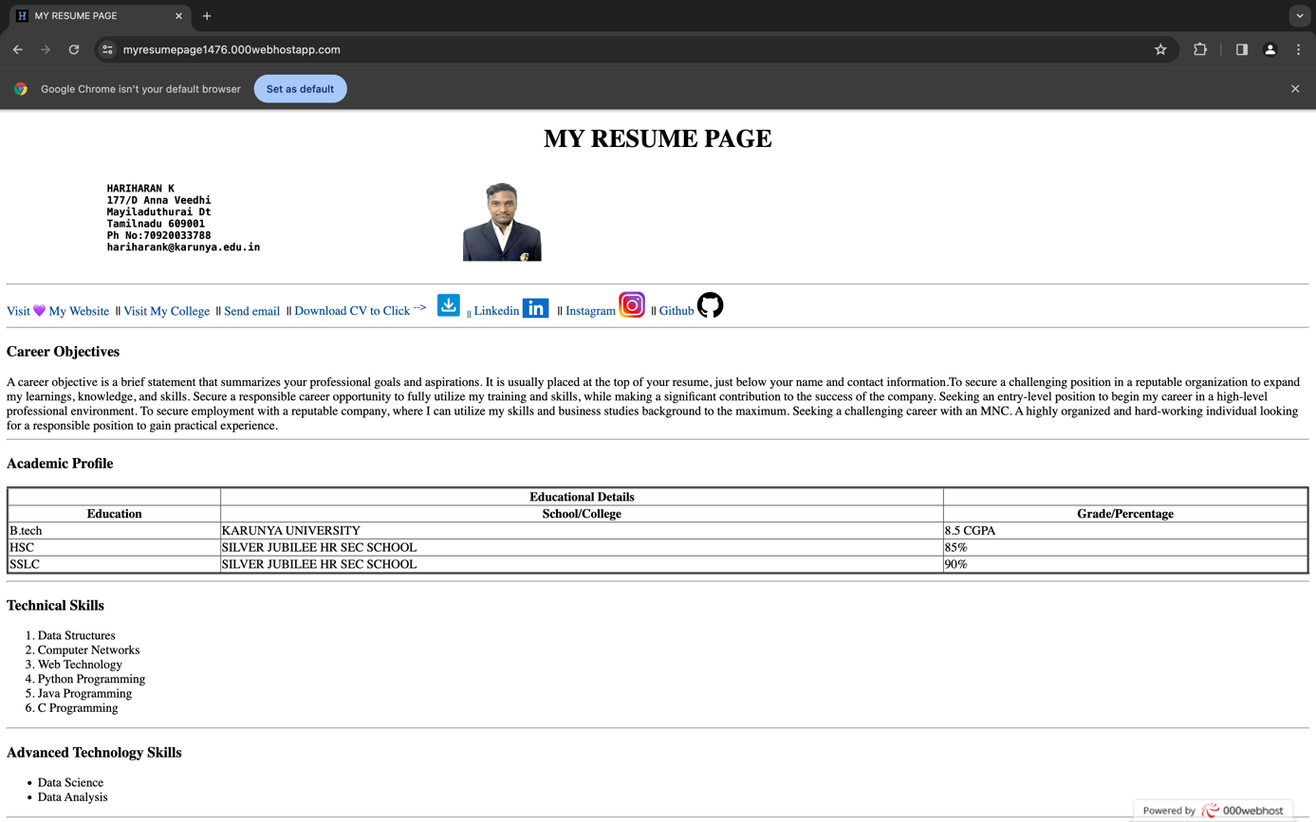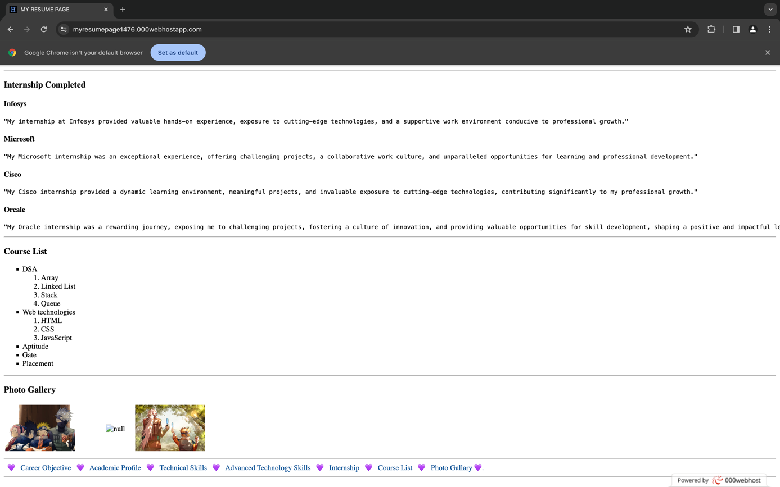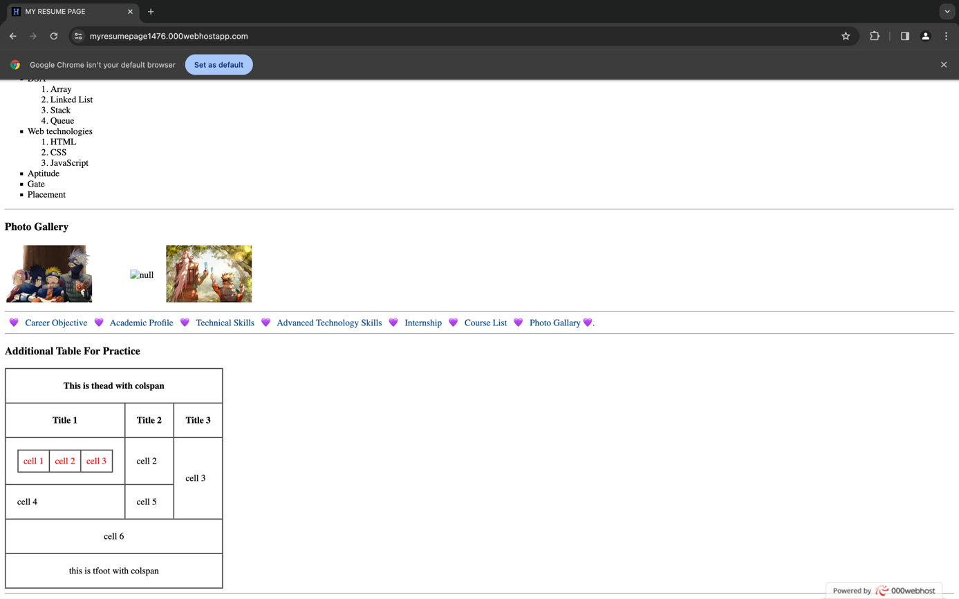

**Result:**

The above HTML5 web page is displayed successfully executed and verified.